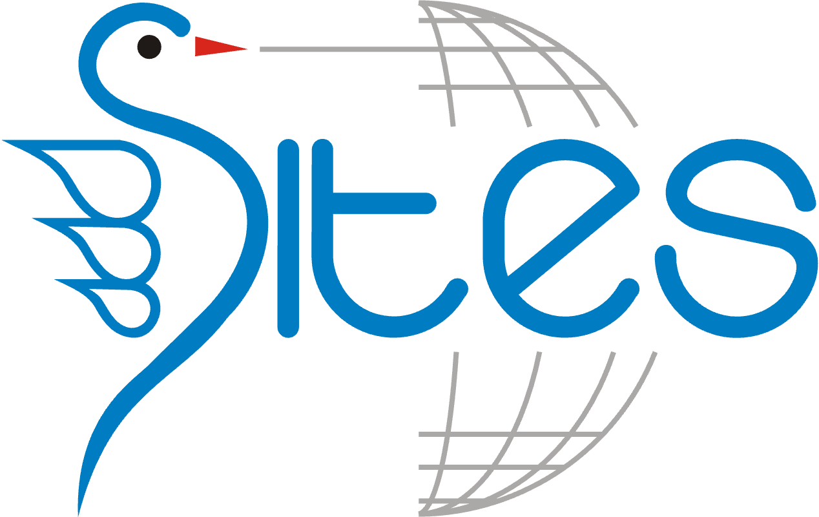  - subscription Campaign 2025  Società italiana di Economia dello Sviluppo (SITES)  Come and Join the Friendly SITES! Make a Difference with us!  Annual Subscription: Seniors - 80 euro, Students - 40 euro  On the SITES web page, click on the bottom JOIN US  What you get: job and research opportunities, connections with development institutions, data, seminars, courses, newsletter.  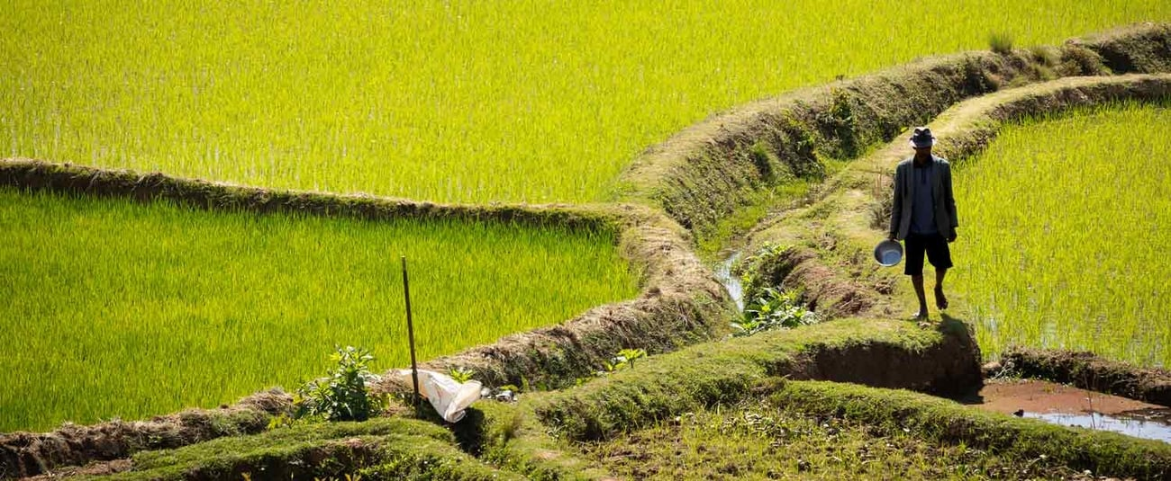 | Do you want to become an economist with high socioeconomic and environmental impact?  ____  Do you want to study the economics discipline with the highest number of Nobel Prize winners?  ____  Do you want to promote sustainable development in a world of peace?  ____  Are you interested in international experiences? … in helping people in difficulty?  ____  Want to learn how to evaluate the impact of development projects?  società italiana di economia dello sviluppo  (sites)  https://www.sitesideas.org/  Subscription Campaign 2025

